SIMATS ENGINEERING
ASSESSMENT TOOL 1

COURSE CODE: MLA03 COURSE NAME: Reinforcement learning for Environment and Agent

COURSE OUTCOME COVERED

CO3: Implement policy-based reinforcement learning methods to develop efficient solutions for complex environments. (BL2, BL3, BL6)

Assessment Tool Weightage: 30%

Dr G. A. SENTHIL
QUESTIONS: 10 | Annexure A | Total Marks: 50
 | CODING CHALLENGE | Duration: 2hrs

1. Predict the Reinforcement Learning (RL) framework by describing the agent– environment interaction, emphasizing the importance of states, actions, and rewards, and discuss how cumulative reward influences decision-making. (5 marks)

Problem Statement
Develop a simple Reinforcement Learning framework that demonstrates the interaction between an agent and its environment. The agent observes the current state, selects an action, receives a reward, and learns to maximize the cumulative reward over multiple steps.

Problem Solving Steps
- Define the environment with three states: Start, Middle, and Goal.
- Define the possible actions: Left and Right.
- Initialize the agent at the Start state.
- Select actions randomly.
- Update the state according to the selected action.
- Assign rewards based on the action taken.
- Calculate the cumulative reward.
- Stop when the Goal state is reached or the maximum number of steps is completed.

CODE
import random states = ["Start", "Middle", "Goal"] actions = ["Left", "Right"] state = "Start" total_reward = 0 print("Simple RL Framework\n") for step in range(5):
action = random.choice(actions) if state == "Start" and action == "Right":
state = "Middle" reward = 5 elif state == "Middle" and action == "Right":
state = "Goal" reward = 10
else:
reward = -1 total_reward += reward print(f"Step {step+1}") print("Action :", action) print("State :", state) print("Reward :", reward) print()
if state == "Goal":
break print("Total Reward =", total_reward)

Output

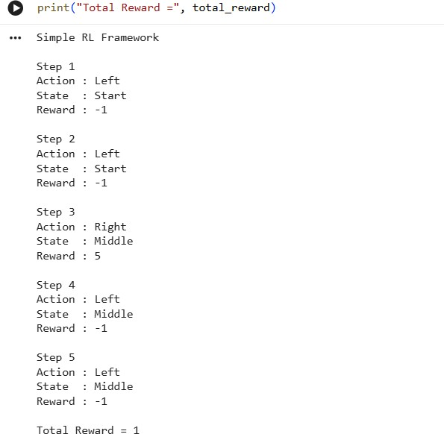

Result
- The RL framework successfully demonstrates the agent–environment interaction.
- The agent learns through rewards received from the environment.
- The cumulative reward indicates the quality of the decisions made by the agent.
2. Estimate how decision-making problems can be modeled as a Markov Decision Process (MDP), detailing the components of action space, transition probability, reward function, and discount factor. (5 marks)

Problem Statement
Develop a simple Markov Decision Process (MDP) to model sequential decision-making using states, transition probabilities, reward functions, and discount factors.

Problem Solving Steps
- Define the states (A, B, Goal).
- Define state transitions.
- Assign rewards for each state.
- Move from one state to another.
- Display rewards after every transition.
- Stop when the Goal state is reached.

CODE
Python
# Coding Challenge 2
# Simple Markov Decision Process states = ["A", "B", "Goal"] transition = {
"A": "B",
"B": "Goal"
} reward = { "A": 5,
"B": 10,
"Goal": 20
}
state = "A" print("Markov Decision Process\n") while state != "Goal":
print("Current State :", state) next_state = transition[state] print("Next State :", next_state) print("Reward :", reward[next_state])
print(" ")
state = next_state print("Goal Reached")

Output
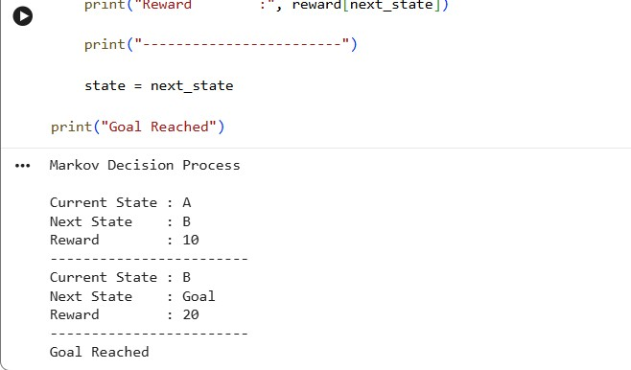

Result
- The MDP successfully models sequential decision-making.
- The agent reaches the Goal state through defined state transitions.
- Rewards help evaluate the quality of each transition.
3. Discuss the role of policy and value functions in RL, and examine how state-value and action-value functions contribute to evaluating long-term benefits of actions using the Bellman Equation. (5 marks)

Problem Statement
Implement the Bellman Equation to estimate the value of the current state using the immediate reward and discounted future rewards.

Problem Solving Steps
- Define the immediate reward.
- Define the future state value.
- Select the discount factor (γ). 4. Apply the Bellman Equation.
- Calculate the current state value.
- Display the calculated value.

CODE
Python
# Coding Challenge 3 # Bellman Equation gamma = 0.9
reward = 10
future_value = 20 current_value = reward + gamma * future_value print("Bellman Equation") print("Reward =", reward) print("Future Value =", future_value) print("Discount Factor =", gamma) print("Current State Value =", current_value) Output

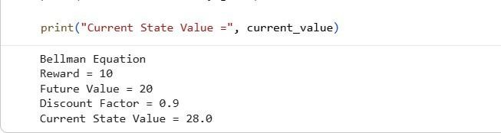

Result
- The Bellman Equation successfully estimates the value of the current state.
- Future rewards are discounted using the discount factor.
- Higher future rewards increase the current state value.

Justify the exploration–exploitation trade-off in RL and compare strategies such as εgreedy and softmax approaches in balancing learning efficiency. (5 marks)

Problem Statement
Implement the ε-greedy strategy to balance exploration and exploitation while selecting actions in a Reinforcement Learning environment.
Problem Solving Steps 1. Initialize Q-values.
- Define epsilon (ε).
- Generate a random number.
- If random number < ε → Exploration.
- Otherwise → Exploitation.
- Repeat for multiple iterations.
- Display selected actions.

CODE
Python

# Coding Challenge 4 # Epsilon Greedy import random epsilon = 0.2 Q = [5, 8, 2, 10] print("Epsilon Greedy\n") for i in range(10):
if random.random() < epsilon: action = random.randint(0, 3) strategy = "Exploration" else:
action = Q.index(max(Q)) strategy = "Exploitation" print("Step", i+1) print("Action :", action) print("Strategy :", strategy) print()
Output

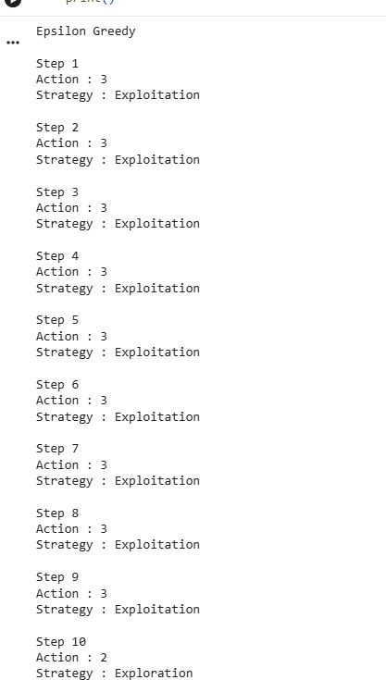

Result
- Exploration allows the agent to discover new actions.
- Exploitation selects the best-known action.
- ε-greedy provides a balance between learning and performance.
5. Illustrate with an example how Q-learning updates the action-value function during training, and demonstrate its convergence behavior. (5 marks)

Problem Statement
Implement the Q-learning update equation to update the action-value function and demonstrate how the Q-value converges toward the optimal value.

Problem Solving Steps
- Initialize the Q-value.
- Define the learning rate (α).
- Define the discount factor (γ).
- Observe the reward.
- Estimate the future Q-value.
- Apply the Q-learning update equation.
- Display the updated Q-value.

CODE
Python
# Coding Challenge 5 # Q-Learning Update alpha = 0.5 gamma = 0.9 Q = 10 reward = 5
future_Q = 20 new_Q = Q + alpha * (reward + gamma * future_Q - Q) print("Q-Learning") print("Old Q Value :", Q) print("Reward :", reward) print("Future Q :", future_Q)
print("Updated Q :", round(new_Q,2))

Output

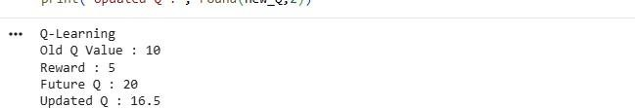

Result
- The Q-value is successfully updated using the Q-learning equation.
- Updated Q-values improve action selection.
- Repeated updates lead to convergence toward the optimal policy.

Code of Conduct:

I G. Rohit Venkat 192472107 certify that this submission is my original work and that I have adhered to the guidelines specified for this assessment.
I understand that any violation of academic integrity rules will result in disciplinary action.

Signature of the student: U. Somesh Kumar

RUBRICS FOR CALCULATION

Criteria | Weighta ge | Level 4 (Exemplary) | Level 3 (Proficient) | Level 2 (Developing) | Level 1 (Beginning)
Technical  Knowledge | 25 | Demonstrates strong and accurate subject knowledge with in-depth understanding | Shows good knowledge with minor gaps | Basic knowledge with noticeable errors | Lacks fundamental technical knowledge
Problem  Solving | 25 | Solves problems logically and applies concepts effectively in real scenarios | Applies concepts with moderate accuracy | Limited problemsolving ability; requires guidance | Unable to solve or apply concepts
Analytical  Thinking | 15 | Analyzes questions critically and provides wellstructured, logical answers | Provides reasonable analysis with some structure | Superficial or partially structured responses | No analytical thinking demonstrated
Communicat  ion | 15 | Communicates  clearly, confidently, and professionally with proper terminology | Communicates well with minor hesitation | Communication lacks clarity or confidence | Unable to communicate effectively
Confidence | 15 | Displays high confidence, positive attitude, and professional behavior throughout | Shows good confidence with minor issues | Low confidence; inconsistent behavior | Lacks confidence and professionalis m
Response to  Questions | 10 | Responds accurately, promptly, and elaborates with relevant examples | Responds correctly but with limited depth | Partial responses; needs prompting | Unable to respond appropriately

